**DIFFERENCE BETWEEN DOCUMENT AND WINDOW OBJECT:**

|  |
| --- |
| **INTRODUCTION** |

The “**Document Object**” represents a webpage structure that is inserted in the DOM tree hierarchy and when compiled the content gets displayed on the webpage. By getting access to the document object, the users can access the HTML webpage content along with the elements by which the webpage is built. On the other hand, the “**Window Object**” is at the head position of the DOM hierarchy showing a window browser or frame.

|  |
| --- |
| **PICTORIAL REPRESENTATION ABOUT DOM VS BOM** |

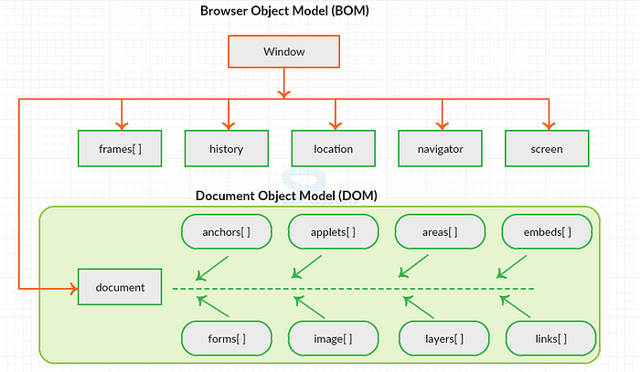

SYNTAX FOR DOCUMENT OBJECT:

document.propertyname;

SYNTAX FOR WINDOW OBJECT::

window.propertyname;

|  |
| --- |
| **DIFFERENCE BETWEEN DOCUMENT VS WINDOW OBJECT** |

|  |  |
| --- | --- |
| **DOCUMENT** | **WINDOW** |
| It represents any HTML document or web page that is loaded in the browser. | It represents a browser window or frame that displays the contents of the webpage. |
| It is loaded inside the window. | It is the very first object that is loaded in the browser. |
| It is the object of window property. | It is the object of the browser |
| All the tags, elements with attributes in HTML are part of the document. | Global objects, functions, and variables of JavaScript are members of the window object |
| We can access the document from a window using the window. Document | We can access the window from the window only. i.e. window.window |
| The document is part of BOM (browser object model) and dom (Document object model) | The window is part of BOM, not DOM. |
| Properties of document objects such as title, body, cookies, etc can also be accessed by a window like this window. document.title | Properties of the window object cannot be accessed by the document object. |
| example:       document.title :  will return the title of the document | example:  window.innerHeight : will return the height of the content area of the browser |